EIFL Case Study: reSearcher integrated suite of open source products in Saint-Petersburg State University Scientific Library

Special thanks to Kevin Stranack, Todd Holbrook, Kristina Long, all Simon Fraser University Library team for the reSearcher project.

Introduction

The Scientific Library of Saint-Petersburg State University (http://www.lib.pu.ru) is one of the oldest and largest university libraries in Russia. It is also a monument of national education, science and culture - by the richness and variety of its stacks it ranks among the most prominent libraries in the world. At present the library contains:
- Collection of print materials - over 7 million units [over 1.5 million titles] (books, journals, dissertations, etc.),
- Electronic collection – 110 licensed information resources (e-books, e-journals, patents, newspapers etc.),
- Digital collection – over 1000 items (Scientific Library of Saint-Petersburg State University and Russian Foundation for Humanities project “Russian book of civil press of the XVIII century”).
Staff of the Scientific Library numbers 293 people (together with faculty libraries). The number of users of the Scientific Library of St. Petersburg University is more than 56,000 students, teachers and employees. 36,000 among them are students. Every year more than 130,000 readers visit the University Library. The number of books borrowed by readers from the library every year is about 1.5 million.

The problem

Electronic resources currently represent a large portion of library resources and are bound to expand and generate an even greater influence on education and information science in the future. Therefore, the methods and means used to acquire and manage them, their licenses, their access, etc., are of significant concern and importance to libraries and information centers.

Figure 1. The quantity of licensed e-resources available to users of the Scientific Library
In 2006 the library needed to employ a qualitative solution giving to users and librarians some functionality on work with electronic resources. During this period there was a doubling in the number of licensed resources accessible for the users of Saint-Petersburg State University (See Figure 1).
In that period the resources were presented on a library site in the form of the static alphabetical list. The page contained only the resource name, the short description and the link to a resource. Description of some resources contained lists of journals in the form of pdf or xls files. The basic problem for users was to find the right resource containing the needed journal, and librarians had no tools for working with electronic journals because of the restricted functionality of their ILS.

Starting the work

In the first six months of 2007 we searched for the available information about the existing open source solutions in the field, studied articles, reports, initiatives and recommendations concerning the problem. We considered the experience of our colleagues from diverse university libraries. And we found reSearcher (http://researcher.sfu.ca), the open source software for libraries, which seemed to be suitable for my task.
In the next half of the year we effected the test installation of the reSearcher platform modules:

- CUFTS: Open Source Serials Management,
- GODOT: Open Source Link Resolving,
- dbWiz: Open Source Federated Searching (not developed and supported since 2010),
- Citation Manager: Open Source Citation Manager (not developed and supported since 2008).

The installation and configuring the system require the experience of working with OS Linux, basic knowledge of Perl programming language, and skills of configuring systems to operate programs written in Perl.
The initial problem concerned the adaptation of the system for working with local resources (not English journal titles). It was partly resolved by changing the source code. The regular updating of the CUFTS journals knowledge database (CJDB) assumes the full-time attention of library staff is available.
GODOT provides OpenURL link resolving, searches CUFTS knowledge base for full text, searches the local catalogue for print holdings, searches other catalogues for remote holdings, and allows for fast ILL (Inter Library Loans) requesting. The module works correctly with ILSs which support the Z39.50 standard, but retrieving bibliographic records with details about the print copy of journal requires adaptation of the existing ILS. In our case the details of item and circulation level were not displayed for the user, since the ILSs for which this have been worked out are only Aleph, Endeavor, III and Sirsi and the Scientific Library uses the IRBIS ILS (Russian solution based on WinISIS database). Also, for the moment the library does not use any ILL system.
At the same time that we tested the CUFTS module, we also examined the commercial product EBSCO A-to-Z® alongside ScholarSFX, which was provided within the scope of the “ScholarSFX™ for eIFL Libraries” project. These were examined as potential alternatives to using CUFTS.
The decision about adopting the reSearcher platform was determined by several factors:
- Favourable feedback from users,
- Statistics showing increased use of the e-resources,
- Free and Open Source Solution,
- Availability of detailed documentation, supporting materials, access to an active community forum,
- The solution was developed by the Simon Fraser University Library (http://www.lib.sfu.ca), it is stably functioning and actively used by diverse organizations as well as by library consortia all over the world,
- The platform provides the possibility of localization (which is absent in the existing commercial products),
- The platform provides facilities for working with resources not in English language.

Outcomes and usage in general practice

In late 2007 the system was moved from pilot (testing) to mainstream operation. The OS used is Debian Linux 4.0 Etch (http://www.debian.org/). Every module works on a separate virtual machine operated by hypervisor Citrix XenServer Free Edition (http://www.citrix.com/xenserver).
A new service of “Electronic Journals” (See Figure 2) for users was created on the library site. It provides:
- Browsing journals by title,
- Searching journals by title, publisher/association/organization, subject and ISSN,
- Links to journals with indicated periods of accessible full text articles,
- Linked lists of available resources containing the required journal with indicated periods of accessible full text articles and embargo periods (if applicable),
- Creating of public or private personal tags.

Figure 2: A screenshot of the “Electronic Journals” user search page
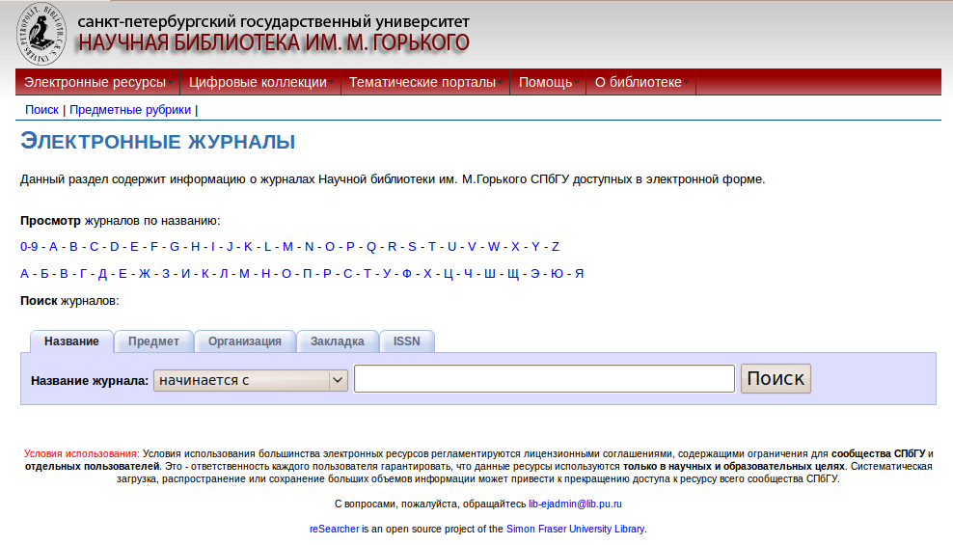

Another new service created for users is “Where Can I Get This?” which is based on GODOT.
A number of resources (ISI Web of Science, Scopus, Ebsco, JSTOR, Gale InfoTrac General Onefile, Google Scholar, ProQuest, PubMed, SAO/NASA Astrophysics Data System, Scirus – Elsevier, Scitation – AIP) were configured to work with local link resolver server GODOT. It provides to users the following facilities:
- OpenURL link resolving,
- Searching CUFTS knowledge base for full text,
- Searching the local catalogue for print holdings.

If the full text is absent on a resource, the user sees a link “Check for full text” or an icon “НБ@СПбГУ”, which leads to a GODOT screen that provides a variety of access options to the researcher:
1. Full text of the article available online:
- Article level link,
- Table of contents for the issue level link,
- Journal home page or a list of articles in the journals,
- Database level link.
2. Searching the local library catalogue for print holdings.
3. Checking the web for the requested item (Google, Teoma).

Users can also save the article citation details directly to bibliographic managers such as Refworks and Sakai Citations Helper.
In addition on the Scientific Library site the user has access to a standalone web interface of GODOT (See Figure 3) to search for the requested item by bibliographic data or by several digital identifiers (DOI - Digital Object Identifier, PMID - PubMed Identifier or OAI Identifier).

Figure 3: GODOT web interface for searching
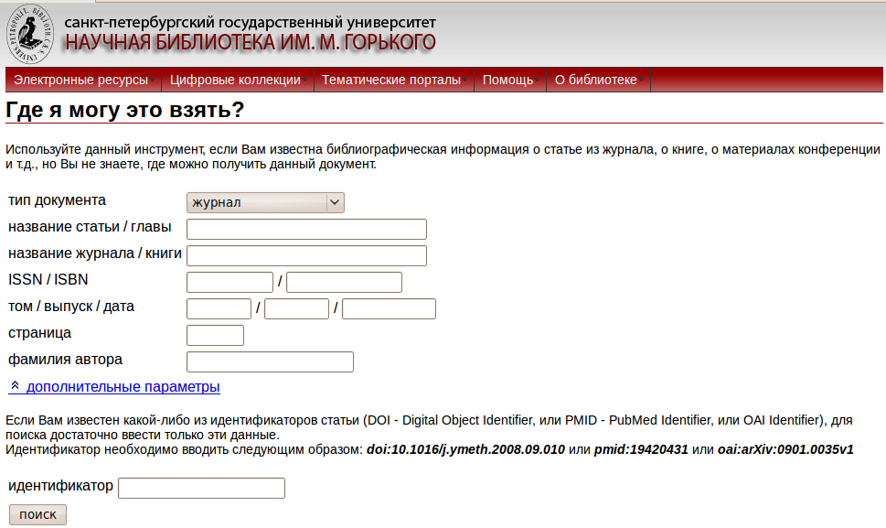

The dbWiz module did not work in production release. It was tested only by library staff.

Also we decided to not launch the Citation Manager module, because the university was actively using Sakai Collaboration and Learning Environment (http://sakaiproject.org/) and the users worked with bibliography via the Citation Helper tool of this system. The library carried out works on customization of interaction between Citation Helper and GODOT. Later, when the academic reference management software for researchers such as Zotero (http://www.zotero.org/) and Mendeley (http://www.mendeley.com/) became widespread, the library created user guides for configuring these programs with GODOT.

During 2008 the services of “Electronic Journals” and OpenURL Link Resolver worked stably and were actively used not only by the university, but also by other academic organizations. The training programs of working with electronic resources which were regularly held for faculty staff and students, included materials showing all the functions of the library system.

In the late 2008 we installed and adjusted the OCLC EZProxy (http://www.oclc.org/ezproxy/) authentication and access software. EZproxy is a customizable middleware program that provides access to your library's licensed content for your remote library users. EZproxy is an easy program to setup and maintain. Configuring CUFTS and GODOT to work with EZProxy is also not difficult. By combining CUFTS and GODOT with EZproxy, the users now can work with licensed electronic resources off campus. At the request of several users from other organizations using our services, on the authentication page additionally we provided a link to the resource without authentication data input, providing the message: “If you are not affiliated with The Saint-Petersburg State University, you can still try to access the licensed resource directly. You may be able to access portions of the site that are not restricted by licensing agreements, or you may be able to access the site because of licensing arrangements provided by your own institution or Internet Service Provider”.

In 2009 the CUFTS module was actively developed. As a result it became a powerful Electronic Resource Management system. Now CUFTS provides basic electronic resource management services, allowing the library to centralize all of the details about its electronic collections, including licensing terms, renewal dates, contacts, and more. CUFTS ERM also features a renewal notification system, reminding you of approaching deadlines and an A-Z list of electronic resources (See Figure 4).

Figure 4: The CUFTS ERM showing the A-Z Electronic Resources list
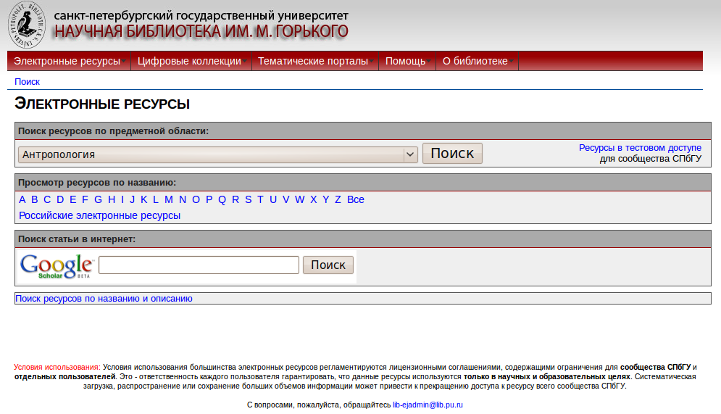

The old static resources list on the library website was replaced by a new service using the CUFTS ERM “Electronic Resources A-Z” feature. As a result users can search, browse resources by subject or title, refine results with resource type, resource medium and content type (database, e-books, e-journals, patents, etc). The resources are grouped as Top Resources and Other Resources for each subject.
In March 2011 developers added the option to create a version of “Electronic Resources A-Z” that is optimized for mobile devices. In this month testing has started at the Scientific Library on this future service (http://cufts.lib.pu.ru/CRDB/SPBGU/m/). So far progress is good, but there are not yet any definite results.

For librarians the CUFTS ERM provides a technical service backbone for controlling the entire life cycle of an electronic resource, offering features including the following:
- Single point of maintenance: The CUFTS ERM provides a single point of maintenance across the CUFTS suite of products;
- Incorporating the Digital Library Federation (DLF) standards for fields to include in an ERMS;
- License management: The ability to query license data elements is a high priority with canned reports on ILL/e-reserve/coursepack restrictions;
- Automatic usage statistics gathering: ERM has the ability to interface directly and automatically with content providers’ systems to download the library’s usage statistics through SUSHI Web services. Libraries can also manually download and store COUNTER compliant usage statistics (Database Report 1 (R3) “Total Searches and Sessions by Month and Database” and Journal Report 1 (R3) “Number of Successful Full-Text Article Requests by Month and Journal”) from content providers who are not yet SUSHI compliant, statistics remain stored in the system and available for reporting until deleted;
- Advanced reporting features: Display and management of click-through, usage statistics and cost-per-use analysis reports;
- Data can be imported and exported from the system in machine readable cataloging (MARC21), XML and plain text formats;
- Variable staff interfaces: different administrative interfaces for different staff groups. This would protect the integrity of data in the ERMS.

Note
- reSearcher was developed by Council of Prairie and Pacific University Libraries (COPPUL) and the BC Electronic Library Network, so the system gets its optimal efficiency when used by library consortia or by associations of several organizations.
- The system has worked at Scientific Library correctly for 3 years and was not accessible only during the software update periods. The system is supported by one IT specialist and one librarian.

Future plans
- Russian localization of VuFind web discovery tool (http://vufind.org/), tuning VuFind to work with CUFTS, GODOT and ILS;
- Russian localization of the Library à la Carte Content Management System (CMS) which enables librarians to easily and quickly create course page, tutorials and subject guides. (http://alacarte.library.oregonstate.edu/);
- Testing the Shibboleth Access Management System (http://shibboleth.internet2.edu/) as an alternative of a commercial product EZProxy;
- Creating a mobile friendly version of library website.

