 | EIFL-FOSS: Free and Open Source programme  Improving ICT infrastructure in libraries
SubjectsPlus: enhanced access to e-RESOURCEs, national university of science & technology Library, zimbabwE
(December 2010 – October 2011)
EIFL-FOSS Pilot Project Report
Full case study
December 2011

SubjectsPlus is a FOSS tool (created at Ithaca College Library in the USA) that enables libraries to create and manage online research guides. Usually created by subject librarians (and therefore requiring no specialist technical skill), these guides can take many forms, with the software sufficiently flexible to allow many different ways of presenting the guides and enabling users to access them (for example, users may want to navigate by subject, by course, by database or by the type of information they seek).

This case study was compiled by Amos Kujenga,Project Lead, from NUST Library, in December 2011 and edited by EIFL-FOSS.

Summary
“Everyone loved it [Sujectsplus] because it is so user- friendly. For the staff members it was easy to create the guides... and at the same time the students were able to access all the information that had been created for them.”
Associate librarian, NUST Library
Question: Can other libraries implement SubjectsPlus?
“Definitely, from the benefits that we’ve received at NUST I can definitely recommend it for other libraries. It helps users, it will help increase usage.
Associate librarian, NUST Library
“What I liked about Subjectsplus is that it is not time consuming for someone doing research. Also every area of study is categorised so there is no way you can get lost. And also within that area of study there are contact details for subject librarians who can help you”
Computer science student, NUST

Problem
Despite many efforts to improve the usage of the e-resources, usage levels have remained low over the years. The challenge of users having to navigate throughout the website to get to the best resource for their particular needs was deemed one reason for the low usage of these resources. Also a tool was needed to help Subject Librarians to easily create and share online subject guides. And finally, due to budget restrictions the solution had to be a FOSS one.

Project
Selected during the EIFL-FOSS call for pilot projects, the NUST library implemented SubjectsPlus (see: http://library.nust.ac.zw/sp/subjects). It serves as a platform for access to both commercial and open access e-resources. The resources are organized into 29 subject areas, providing easy access to a variety of e-resources in each area, including journals, books, dissertations, and exam papers. The contact information for each subject librarian is also included in the subject guides. In addition, a reference chat feature was implemented to make it easy for patrons to easily contact librarians. Finally, a google search engine was implemented for users who prefer to search versus browse by subject.
Both patrons and Subject Librarians were targeted as beneficiaries. Patrons benefit through enhanced access to resources and Subject Librarians are now more visible to their patrons, raising their profile, and also they now have a tool to facilitate the creation of online subject guides.

Key achievements
- There was an impressive improvement in the usage for some of the Library’s most popular e-resources soon after the new SubjectPlus website was launched
- Launch of a library gateway from which users can access both licensed and open access e-resources
- Creation of 29 online subject guides
- Creation of a website that allows for easy implementation of related tools, including Google search and an online reference chat service
- Library staff became proficient in a new technology
- The project resulted in support from library management and the purchase of laptops to promote SubjectPlus during visits to academic departments
- A team member presented the project at EIFL-FOSS 2011 Regional Seminar in Tanzania; it received a positive response, seven delegates from other countries expressed an interest to implement SubjectsPlus.

Introduction
The National University of Science and Technology (NUST) Library is situated in Bulawayo, Zimbabwe. It serves the university’s student population of about 6500 and approximately 750 members of staff and has three branch libraries. Its vision is “to be one of the top class academic Libraries in Zimbabwe, utilising new and emerging technologies in the provision of service and information to the University community.” As its mission, NUST Library exists to provide all staff and students with information resources using state of the art tools and methods in support of the University’s mission.
Owing to the growing demand for resources due to ever increasing student numbers, the library is now focusing on electronic resources that it subscribes to mainly through the Zimbabwe University Libraries Consortium (ZULC). While efforts have been made to improve the usage of these resources through, for example, an on-going, on-demand Information Literacy Skills (ILS) training programme and other initiatives, usage levels have remained low over the years.
The challenge of users having to navigate throughout the website to get to the best resource for their particular needs was deemed one reason for the low usage of these resources. The project, therefore, sought to tackle the problem of discoverability of electronic resources and at the same time help streamline ILS training programmes.
With Zimbabwe coming from a decade long economic meltdown, recovery has been slow and budgets remain tight. A FOSS solution was ideal in order to cost-effectively cater to the ever growing demands since it can be scaled or expanded at will.
FOSS is not new to NUST Library that has been actively involved in EIFL-FOSS activities since the beginning of the EIFL-FOSS programme more than five years ago. For example, the library’s website runs on Drupal while there is a digital library running on Greenstone and an institutional repository running on DSpace. All these systems are accessible online.

Project Description
The project aimed to enhance service delivery through the improved discoverability of both subscribed and open access electronic resources. This was expected to boost usage levels and was to be achieved by making it easy for Subject Librarians to add different types of resources to subject guides. The move would also ensure that the site content was updated efficiently without the need to wait for technical staff to effect changes.
SubjectsPlus was identified through an Internet search by the Library’s technical staff. There were no institutions nearby known to be using this kind of software application and so this was a bold move. A few years before, another FOSS solution, Research Guide had been trialled but it had since been noticed that there had been no activity around it for some time and so it was dropped.
SubjectsPlus is a web based Free and Open Source Software (FOSS) tool that can be used to manage several interrelated parts of a website. These include:
- Subject, Course, or Topic Guides;
- A-Z list of databases;
- Frequently Asked Questions;
- Suggestion Box (or Talkback);
- and a Staff list.
It runs under the XAMP (Linux/Windows-Apache-MySQL-PHP) environment.
Both patrons and Subject Librarians were targeted as beneficiaries. Patrons benefit through enhanced access to resources and Subject Librarians are now more visible to their patrons, raising their profile, and also they now have a tool to facilitate the creation of online subject guides.

Implementation of the FOSS Pilot Project
A typical installation of the software only takes a few minutes. At NUST Library, SubjectsPlus was initially installed on a test server before being run on a (Linux) Fedora Core 14 server that is also hosting the library’s recently updated website running on Drupal. Initially, plans were to have it embedded within the Drupal installation but some technical challenges that were slowing down progress resulted in this plan being abandoned. However, this idea will be revisited so that there is a seamless link with the rest of the library’s website. At present the Subject Guides created through SubjectsPlus can be seen in a link to 'Research Guides' at the top of the library's homepage (see Figure 1) and also under the research Support section.
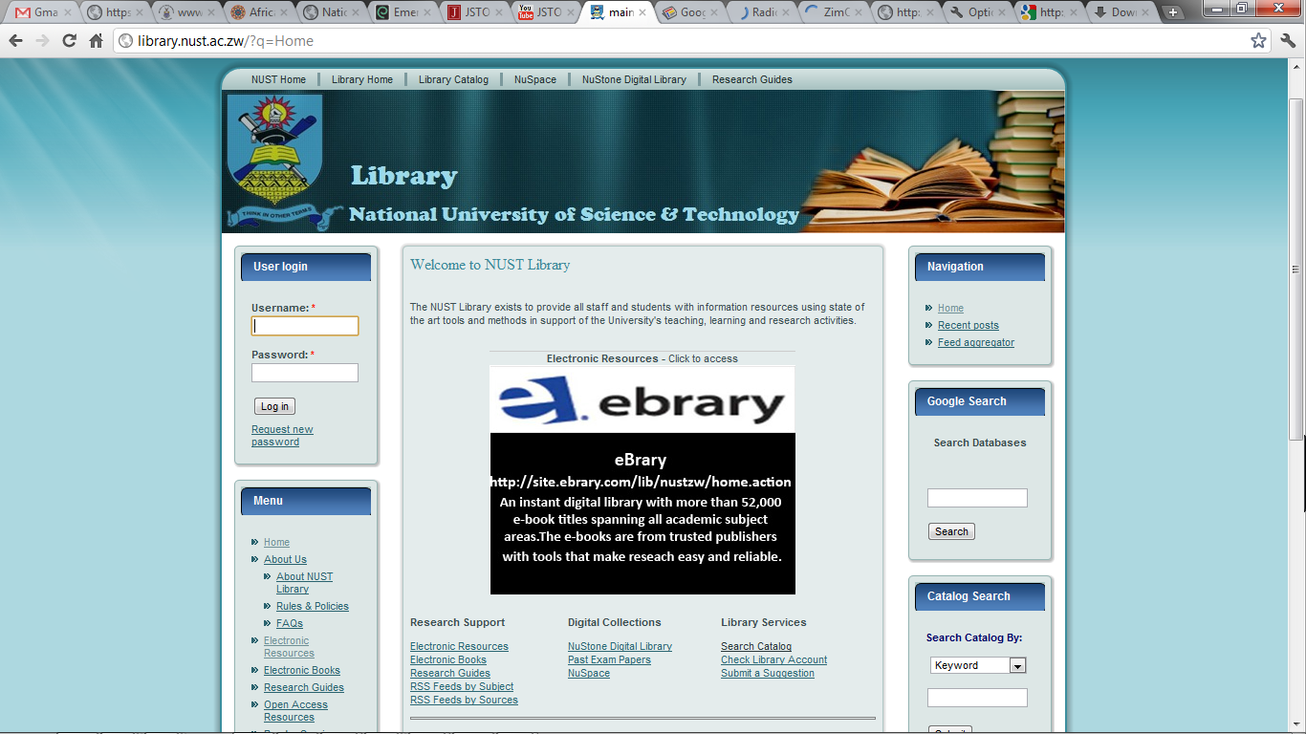
Figure 1: The NUST Library website’s home page showing links to SubjectsPlus
Some of the customisation that was done included changing the colour of the interface and creating a custom menu. In addition, other functionality was added, including Google Custom Search engine within the guides to enhance the user’s experience. This facility that is freely available through Google, can be used to create custom searches by specifying the sites to be searched. This means it can act as a federated search tool, using the Internet’s most popular search engine that is also popular with library users. Moreover, the tool can be configured such that the user can click to display results from a particular site only.
A Meebo widget was also included in the implementation. This free facility allows patrons to chat online with a librarian and can be used to provide instant digital reference services. Figure 2 shows the NUST Library Guides homepage – note the “extras” on the right side, i.e. a flash slideshow with links to Journal Databases and a Google Custom Search form.
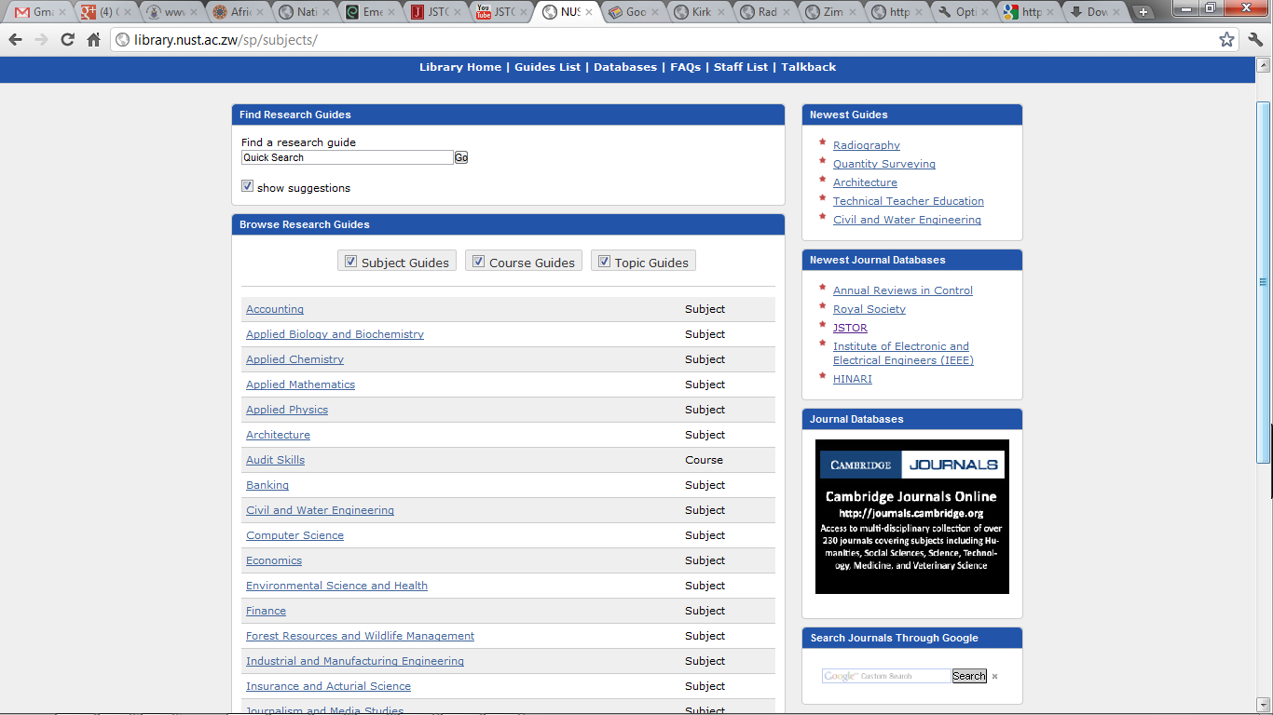
Figure 2: The NUST Library guides list page.
The subject guides are arranged by department and are available online on http://library.nust.ac.zw/sp/subjects.

Partners and key roles
Library staff (mostly made up of Senior Library Assistants and Assistant Librarians) were trained in the use of the software. Two training workshops were held and a demonstration session conducted to familiarise members of staff with guided search tools since this software was new to many of them. Users were also given post-training support through ad hoc one-on-one sessions.
Although Assistant Librarians play the Subject Librarianship role at NUST Library, management felt that it was best to involve other library staff and form teams to work on the guides. Assistant Librarians then performed the role of team leaders in groups created for each faculty to create the content for the guides. They were supposed to liaise with academics in their respective departments to make sure that the guides contained the right information.
Library management were involved in the project and supported it throughout its duration. This support included the acquisition of laptops, one of whose major functions is to be used by Assistant Librarians in promoting the initiative during visits to academic departments.
Technical assistance was received from the SubjectsPlus wiki, video tutorials, mailing list, and also through direct emails and chats with the software’s principal developer, Mr Andrew Darby. The Project Leader, Mr Amos Kujenga, had been introduced to Mr Darby through the EIFL-FOSS Programme Manager.

Benefits and impact
There has been an impressive improvement in the usage statistics for some of the Library’s most popular databases such as Emerald and JSTOR since the guides went live in July, soon after the new website was launched. Figures 3 and 4 show some statistics for Emerald.
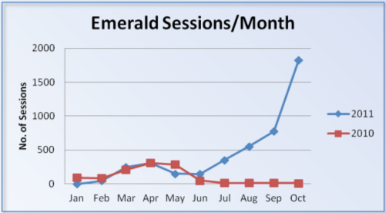 | 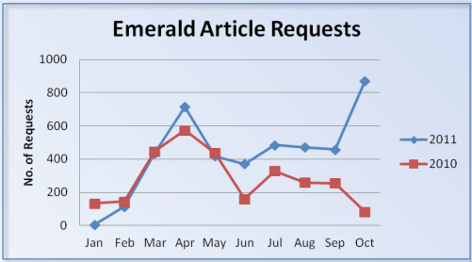
Figure 3. Emerald sessions per month Figure 4. Emerald article requests
Throughout the year of the project, there have been many presentations on the project. Attendees have been inspired by the success of the NUST library and expressed enthusiasm to implement it at their own institutions.
In June 2011, the Project Leader made a remote presentation of the initiative at the annual EIFL General Assembly in Minsk, Belarus. The presentation attracted attention in so much that a workshop was proposed abroad although it had to be shelved as the Project Leader was not available due to other commitments.
The project was also showcased during the EIFL-FOSS Themed Week on SubjectsPlus in October 2011. Although connectivity problems affected the live presentation, participants were directed to a pre-recorded video as a fallback measure and the feedback was impressive. After the event, one participant from a Zimbabwean university wrote: “... we are looking forward to seeing more of SubjectsPlus workshops both on line and physical it is an interesting package that seems to be having a future at our institutions”. Another Zimbabwean participant made the following comment via email: “...we managed to get the ideas behind SubjectsPlus. Definitely you will be approached for further assistance...” A highly experienced information professional who is based in South Africa but travels around Africa said in a chat message while he was in Ethiopia that he was interested in the software and wanted to set it up for his organisation’s resources. These and other comments magnified the need for further dissemination of the software and skills to other institutions around Zimbabwe.
In November 2011, NUST Library shared its experiences with library directors and FOSS champions from the EIFL community in Africa at a Regional Seminar held in Dar es Salaam, Tanzania. Of the participants six said that they would implement SubjectsPlus.
In December 2011, eleven institutions across Zimbabwe attended a national workshop sponsored by EIFL. At the workshop participants received hands-on experience with implementing SubjectsPlus. The participants expressed enthusiasm and interest in implementing it at their own institution.

Success Stories
The SubjectsPlus supports two audiences: it enables librarians to create online guides and manage online content; and it provides end users with an easy to use interface to browse or search for resources.
Librarians on the project found it easy to implement and it helped them to better serve their patrons.
“Everyone loved it [Sujectplus] because it is so user- friendly. For the staff members it was easy to create the guides... and at the same time the students were able to access all the information that had been created for them.”
Associate librarian, NUST Library
Question: Can other libraries implement SujbectPlus?
“Definitely, from the benefits that we’ve received at NUST I can definitely recommend it for other libraries. It helps users, it will help increase usage.
Associate librarian, NUST Library
From the perspective of the patron, the interface is easy to use and very helpful. A final-year Computer Science student interviewed said that he liked the system as it was not time consuming to use and there was “no way to be lost” because of the way the guides are arranged by department. He also appreciated the fact that details of the Subject Librarians for each area are included which thing helps patrons to know where to get further assistance.
“What I liked about Subjectplus is that it is not time consuming for someone doing research. Also every area of study is categorised so there is no way you can get lost. And also within that area of study there are contact details for subject librarians who can help you”
Computer science student, NUST

Lessons Learned
Even though the technical staff at NUST Library are well experienced with FOSS used in libraries, SubjectsPlus may be unique in that the level of expertise needed to get it going is quite low when compared with other FOSS tools. However, other libraries wishing to implement it can learn from the NUST experience. Furthermore, the technical staff at NUST Library are at hand to assist other institutions planning to use SubjectsPlus.
Management support is critical for the success of such a project. Responsibilities should be clearly defined and made to be part of daily duties. Management should also ensure that, for example, those responsible for creating guides, are motivated and do not view the work as unnecessary extra workload. The formation of teams to work on the guides at NUST Library helped to create an atmosphere in which all were made part of the team.
Building guides that benefit patrons requires time, effort, and coordination of stakeholders. It is important to engage end users early in the project as this helps to ensure that the right content is uploaded and the initiative does not become a white elephant. At NUST Library, some of the challenges experienced include the lack of engagement of end users when uploading content. This concern was highlighted to one of the Subject Librarians when he conducted an onsite demonstration to members of staff in his faculty after creating guides for them.

Conclusion
SubjectsPlus, together with other tools such as the Google Custom Search facility have helped improve the usage of electronic resources at NUST Library. The software is set to be even more useful as NUST Library recently acquired (Web Access Management) proprietary software that allows its patrons remote access to subscribed electronic resources. This should also show that FOSS can be used together with proprietary software. Furthermore, plans have been put in place to replace the current server with a more powerful machine next year so as to improve system performance.
While the focus to date has been on the creation of subject guides, course and topic guides will also be developed with time.
As before, NUST Library will continue to take up every opportunity to promote the use of SubjectsPlus and other FOSS applications that can be used in libraries and to encourage other institutions to do the same.
N.B. Videos of interviews are available on http://www.youtube.com/nustlibrary

FURTher information about SUBJECT PLUS
- Languages: Any
- EIFL users: Zimbabwe: National University of Science and Technology
- Homepage: http://www.subjectsplus.com
- Download page: http://www.subjectsplus.com/download.php
- User community: http://groups.google.com/group/subjectsplus
- Learn more: see our SubjectsPlus information page, giving details of the EIFL FOSS Themed Week by Andrew Darby and Amos Kujenga, and also our 2011 Regional Seminar to view Amos Kujenga's presentation materials and a copy of the software to download (look for two sessions: Pilot Knowledge Sharing SubjectsPlus and also Access To Resources Training Session).

