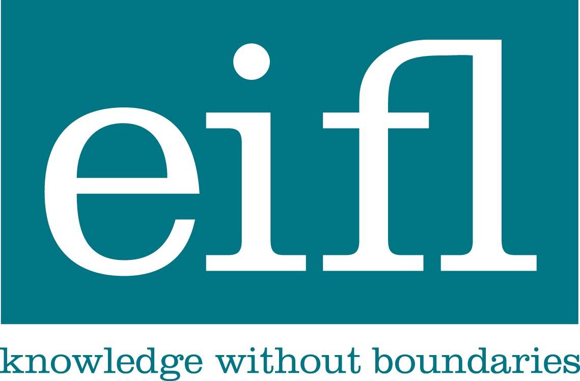
EIFL-FOSS: Free and Open Source programme
Improving ICT infrastructure in libraries

disability tools for visually impaired users, university of zimbabwe library
(JANUARY 2011 – OCTOBER 2011)
EIFL-FOSS Pilot Project Report
Full case study
November 2011

Disability tools. There are a many FOSS tools which can be used to support library users with disabilities. These include tools to aid viewing of the screen (such as magnification, colour change), tools to aid usability (e.g. making the cursor more visible), tools to aid reading (e.g. text-to-speech tools in many languages), information presentation tools (e.g. mind mapping software) and more. A great place to begin is the AccessApps package, a suite of over 60 open source and freeware Windows applications which run from a USB stick. AccessApps provides a range of solutions to support writing, reading and planning as well as specific disabilities.

This case study was compiled by the project team: Yeukai Chimuka, Tendai Mataranyika and Darlington Musembur from the University of Zimbabwe in November 2011 and edited by EIFL-FOSS.

Summary
‘I am now able to read for myself because of the virtual magnifying glass thanks to you.’
Student at University of Zimbabwe

‘I now enjoy my studies just like any other students I no longer feel segregated’.
Student at University of Zimbabwe

‘Ah!! Now I can read my documents without problem’.
Lecturer in the Department of Adult Education, University of Zimbabwe

Problem
The University of Zimbabwe Library has embraced technologies to maximize access to information resources that support teaching, learning and research. However like most university libraries in developing countries, ICT infrastructure has not been adapted to suit the needs of the deaf, blind, visually impaired and physically challenged. UZ library therefore sought to harness Free and Open Source Software (FOSS) to meet the needs of the disabled community by involvement in a pilot to implement FOSS disability aids.

Project
Selected during the EIFL-FOSS call for pilot projects, The UZ library identified the FOSS tools that would best meet the needs of students with visual disabilities and installed them on computers in the library and also on students’ laptops. In addition, they formed a partnership with the UZ Disability Resource Centre (DRC) so they could more effectively reach students. The DRC installed the FOSS disability tools on the computers in their own computer lab. The partnership with the DRC also included the library providing training of visually impaired students as a permanent feature of new students’ orientation.
Early on in the project the core UZ Library team attended free, online training offered by EIFL on how to implement and use the visual disability tools. Then, those who attended, in turn conducted training for the rest of their library staff. The Library staff were excited about the project and fully supported taking on this new role.

Key achievements
- Successfully providing disability tools for 20 students with visual disabilities
- Training UZ reference library staff to assist students to use the disability tools
- Forming a new partnership with Disability Resource Centre (DRC) to ensure for long-term sustainability of the project
- Increased visibility of the library by university administration and by government officials at the Ministry of Public Affairs
- Nomination of the project for a prestigious UN award
- As a result of the project submitting its final reports to EIFL-FOSS one of the team members was invited to the EIFL-FOSS 2011 Regional Seminar held in Tanzania in November 2011 to speak about the project. The project received an overwhelming response from the participants with delegates from six other countries expressing an interest to implement the tools in their library and across their library consortium.

Introduction
The University of Zimbabwe Library is situated in Zimbabwe’s capital city Harare. It is the oldest (established 1958) and largest academic Library in the country.
The Library provides access to both print and electronic resources including e-journals and e-books databases and other locally digitized materials. The University of Zimbabwe Library is now fully automated and moving towards fully digitizing its collection. Open Access resources compliment the library’s e-resources collection and the library also has local digitized materials which include the Institutional Repository (IR) and online databases of e-theses and past examinations.
The University of Zimbabwe Library serves the university community (which includes students and staff - both academic and non-academic), external users from the public and private sectors, and users from abroad who may require information available in the Library. Among the library patrons are also users with different disabilities, the greatest proportion of which is visually impaired users. The Library realized that this was a category of users whose information needs were not being met effectively and the Library explored ways of meeting the information needs of users with visual impairment. Commercial tools proved to be very expensive, hence opting for Free and Open Source Software (FOSS).
In November 2010 there was a call for pilot projects from EIFL-FOSS and the University of Zimbabwe Library saw it as an opportunity to explore the tools for visually impaired users. The proposal was approved and Library staff received training organised by the EIFL-FOSS programme manager Simon Ball.

Project Description
The University of Zimbabwe Library has embraced technologies in maximizing access to information resources that support teaching, learning and research. However like most university libraries in developing countries, ICT infrastructure has not been adapted to suit the needs of the deaf, blind, visually impaired and physically challenged. UZ library therefore sought to harness Free and Open Source Software (FOSS) in meeting the needs of the disabled community by involvement in a trial of some FOSS disability aids. The rationale for implementing these tools was:
- To enhance the presence of an already automated library environment.
- To make the significant population of visually impaired users (ranging from partially sighted to the blind) independent users of information.
- To enhance equal access to available electronic resources.

Implementation of the FOSS Pilot Project
In November 2010, the UZ library submitted a project proposal for the use of FOSS disability tools under the EIFL-FOSS call for proposals. By December 2010, the proposal was approved, thus UZ library was given the mandate to pilot the Disability Tools Project from February 2011 to September 2011.
In February 2011 the project team (comprising Yeukai Chimuka, Tendai Mataranyika and Darlington Musemburi) attended an online training workshop on the use of the tools facilitated by EIFL-FOSS Programme Manager Simon Ball. After the training, the project team conducted a test run of the disability tools for visually impaired students. The project team realised the need for training for all library staff and organised training in March 2011 for 20 library staff members.
From March 2011 efforts have been and are continuously being made to publicise the project within the university community. Key stakeholders at the university such as Dean of Students, Disability Resource Centre Coordinator and academic staff were introduced to the use of these applications.
Visually impaired students were identified through their own social networks; visually impaired students became recruitment agents for other students with similar challenges. This was efficient and effective, such that by April 2011 a total of 20 student champions had been registered.
During the beginning of the 2011/2012 academic calendar, the team organised orientation for all new students with visual impairment to prepare them for use of the application tools. Efforts were made to reserve two computers in the library for use by students with visual disability. The photo below shows students attending training in the use of the application tools.
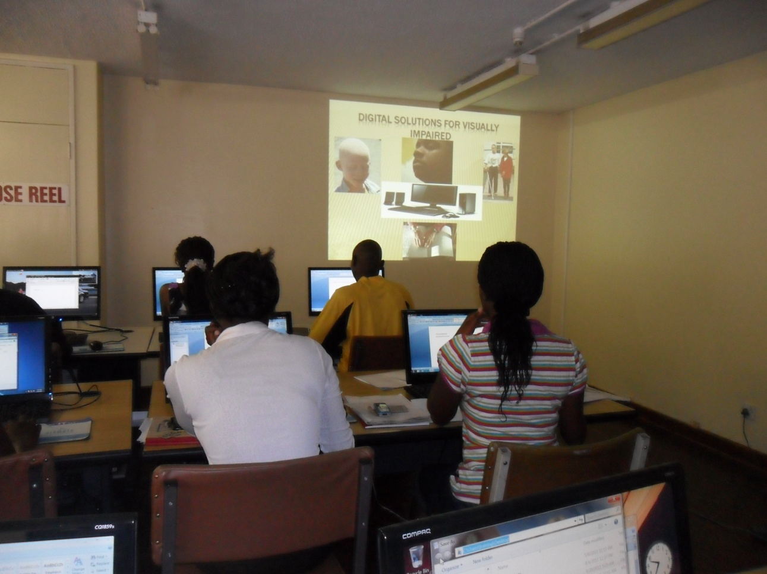

Students learn about access tools during
new student orientation week
The most popular tool was 'Virtual Magnifying Glass' since most of our users have difficulty using computer screens, the virtual magnifying glass is an easy way to assist them. The students who had benefited acted as 'champions' and informed other visually impaired students, who in turn came to the library to get trained and have the software downloaded onto their laptops. FOSS tools were also installed on some PCs in the Library.
After the overwhelming response from the users, the team found it necessary to train the rest of the Library staff who assist users so that they could assist when the need arose. The Library staff were excited about the project and assured the team of their full support.
The coordinator and technical advisor of the UZ Disability Resource Centre (DRC) Mr. Chinyoka (who is also visually impaired and is a graduate of the University) offered to assist in marketing the project to his colleagues. The project team entered into partnership with the DRC and came up with a plan to include training of visually impaired students as a permanent feature of new students’ orientation week starting in August 2011. The DRC offered to help in identifying potential users for the disability tools and referred them to the Library. The DRC agreed to have the tools installed on all the computers in their PC lab and allowed the project team to train the lab's regular users in the use of the tools. DRC has also trained all of the DRC staff on the use of the tools. DRC also helped the project team with identification of other organisations which may benefit from these access tools. The team is planning to take the tools to these organisations and offer training to the people responsible for implementing or supporting them there.
There are two computers set aside for these access tools in the Main Library while a place identified to house these tools is under construction. Users who need to use these tools get priority in using these computers when the need arises. Currently the University of Zimbabwe has 20 students with visual disability and most of the time they use the computer laboratory at the DRC so the project team has allocated five data sticks containing the access tools for use in the DRC computer lab. One of the features of these access tools that the students appreciate, however, is that they can use them at any PC and therefore they no longer feel segregated from the other students.

Benefits and Impact
The outcomes have been much greater than originally envisaged. The University Executive Administration took the project to the Zimbabwe International Trade Fair (ZITF) in May 2011 where many people showed interest in the project. After the ZITF exhibition, the project attracted a lot of attention including the Ministry of Public Affairs which requested UZ to take the project to Tanzania and exhibit it at the United Nations & Africa Public Service Day in June 2011. As a result the project has been recommended for a UN award.
On a more local level, the tools have become an important part of the lives of the 20 students with visual impairment who have received training. These students mainly use the virtual magnifying glass and the text-to-speech tool D-Speech. In some cases they use Power Talk for reading aloud the content of Microsoft® PowerPoint presentations.
Quotes from the patrons who have used the tools included:
- ‘I am now able to read for myself because of the virtual magnifying glass thanks to you.’
- ‘I now enjoy my studies just like any other students I no longer feel segregated’.
- ‘Ah!! Now I can read my documents without problem’.
The latter quote is from a lecturer in the department of Adult Education whose eyesight was affected by diabetes after using the virtual magnifying glass for the first time.
As a result of the project submitting its final reports to EIFL-FOSS one of the team members was invited to the EIFL-FOSS 2011 Regional Seminar held in Tanzania in November 2011 to speak about the project. The project received an overwhelming response from the participants with delegates from six other countries expressing an interest to implement the tools in their library and across their library consortium.
Also of interest is that the wider university community beyond the Library is now aware of the access tools. For example, the Dean of Education referred a member of academic staff with visual impairment to the Library for assistance. The team has since installed the tools on the staff member’s PC and the staff member is excited about the tools. He has agreed to act as a champion for the use of the tools amongst staff with visual impairments.
The other benefit is a strengthened relationship between the DRC and the Library, meaning that disabled students now feel as welcome and supported in the Library as well as in the DRC, so they feel less segregated from other students.
An article about the project was written by the team and it was published in the inaugural edition of the University of Zimbabwe “Intellect” publication (an academic magazine which was launched in October 2011).

Lessons LearnED
- It is worth ascertaining demand for access tools in most Libraries and information centres, as there is probably considerable demand for them.
- A successful project or pilot with this kind of tool is very much dependent on the participation of the beneficiaries themselves. They must feel that their participation and feedback is worthwhile.
- Issues to do with access to digital information for visually impaired people are not often prioritised, and projects using FOSS tools can help demonstrate their value.
- The University Executive can be a key partner in the marketing the success of such a project.
- Training in the use of the Disability tools is necessary for the effective and efficient use of the tools. The training of all staff, not just those in regular contact with disabled students, is recommended.
- Identification of, and consultation with, key stakeholders is necessary for the success of the project. The collaboration with the university's DRC greatly enhanced the impact of this project.

Conclusion
In conclusion, the Disability access tools at the University of Zimbabwe could not have come at a better time, as they have become important tools which enable our users to access the increasing number of e-Resources. With the overwhelming response from the users, staff, university administration and the Government, the future of FOSS Disability tools in Zimbabwe looks bright. The University of Zimbabwe Library plans a nationwide distribution and training programme with the disability access tools – over 100 data sticks have been donated for this purpose by JISC TechDis, a UK organisation increasing access of disabled students to higher education through technology. The University of Zimbabwe Library has already identified organisations in Zimbabwe which might need these access tools.
The Library also plans to explore other FOSS tools which will help users with visual impairment including those who are totally blind. Such tools as NVDA (a screen-reading tool to assist the completely blind) will be explored to assist the totally blind users in accessing e-resources and using the University of Zimbabwe’s e-learning platform, a vehicle used in delivering course materials by lecturers.
The University of Zimbabwe Library is grateful to the EIFL FOSS programme for entrusting them with the FOSS project. UZ Library looks forward to continuing partnering and collaborating with EIFL on similar and other projects that benefit Library users.

Further information about Disability Tools
- Languages: Varies - for example Balabolka, the text-to-speech tool, is configured for 21 languages, with Help files in 6 languages. For a package of Arabic FOSS Disability Tools see http://ma3bar.org/miftaah
- EIFL users: University of Zimbabwe
- Homepage: A good overview of many of the tools available can be found at http://www.jisctechdis.ac.uk/techdis/technologymatters/enablingtech/FOSS
- Download page: To download AccessApps go to http://eduapps.org/?page_id=52
- Licence: It varies for each tool. AccessApps is free only for educational purposes.
- User community: Join some of the mailing lists at http://www.jisctechdis.ac.uk/techdis/aboutus/keepintouch
- Developer community: It varies
- Learn more: View the University of Zimbabwe case study and take a look at the EIFL FOSS Themed Week online workshop on Disability Tools at http://www.eifl.net/news/eifl-foss-first-themed-week-success

