
EIFL-FOSS Case Studies

Case Study: Armenia Evergreen ILS pilot

This case study was produced in June 2009 – an update from December 2010 is included at the end.
Project overview
The EIFL-FOSS ILS projects provided an opportunity for evaluation of (and possible migration to) a free and open source software (FOSS) integrated library system (ILS), to promote direct engagement with the FOSS communities of the chosen ILS and lay the groundwork for a mutual support network across the EIFL network for further libraries investigating migration to a FOSS ILS. The projects focused on evaluating one of two FOSS ILS tools with robust and open development and support communities: Koha (www.koha.org) and Evergreen (www.open-ils.org). Following a general call for participation in early 2008, several sites were selected that represented a wide range of libraries and regions. Each pilot library participating in the project was invited to participate in an intensive technical training workshop in Yerevan, Armenia, in June 2008.
Armenia Evergreen pilot
Background and selection of Evergreen
The Fundamental Scientific Library of the National Academy of Sciences (FLIB, www.flib.sci.am) has been a dynamic space of creativity, a source of knowledge and a place for learning and research welcoming researchers, students, and academicians from different subject areas since 1935. The library has more than 3 million physical documents in various media in all fields of science. The project was led by Library Director Dr. Tigran Zargaryan, who wished to investigate a move to a FOSS ILS system from the ExLibris ALEPH system (with legacy data in MARC21 format) which required substantial technical knowledge to administer and had significant costs involved in licensing fees and maintenance and support contracts. In addition to the legacy ALEPH ILS, the library also employed WinISIS and IRBIS databases. After extensive trials also with Koha, Evergreen was chosen purely on a technical criterion that could not have been guessed without trials, namely that it handled much more successfully records in Armenian and Russian script.

Training workshop
The Fundamental Scientific Library in Yerevan hosted the initial training workshop for all of the EIFL-FOSS ILS pilots. During those few days experts from the Evergreen and Koha development communities were on hand, and the attendant ILS pilot teams were able to gain significant hands-on experience. Whereas each of the other pilot sites were only able to have one person attend the workshop, many technical staff from FLIB participated, dividing their time between the Koha and Evergreen training.

Translation and international impact
Tigran committed early on to providing an Armenian translation for the Evergreen and Koha user interfaces, meaning that other libraries in Armenia can consider equally Koha and Evergreen as their next ILS. The contribution of a testing set of Armenian records has now become a standard international testing tool for new versions of Evergreen, helping to establish its credential as a viable FOSS ILS for countries outside North America. This is remarkable as an example of an EIFL library engaging with a typically generous and helpful FOSS support community.

Building a network of local and regional support
FLIB committed itself to a leadership role across the libraries in the National Academy of Sciences through participation in this project. In April 2009 staff at FLIB hosted a 2-day workshop for staff from the Ilia Chavchavadze State University library in neighbouring Georgia. This was an opportunity to share experiences since this Georgian library had already begun testing Evergreen. It was also an opportunity to build a regional network of Evergreen users.

Learning Points from the pilot
There have been numerous learning points from this pilot. A few may be unique to FLIB but most have wider application.
- FOSS solutions need to be at least as technically proficient as any proprietary system they are destined to replace.
- A wide portfolio of watching briefs on possible future systems can provide needed continuing professional development for library staff.
- Early investigation of FOSS alternatives may bring benefits when financial challenges make proprietary solutions untenable.
- Technical differences, where they exist, between comparable FOSS systems can be decisive, but discovering these may require considerable time and effort.
- Leadership often demands that one library undergo the pain of piloting a new solution before confidently recommending it to others.
- Banding together with other local or regional users of your preferred FOSS ILS is a great way to increase the support resiliency of the FOSS community.
- A close association with a FOSS development community will almost certainly benefit your use of that software.
- Once you begin making practical contributions to a FOSS community your contributions continue to benefit both you and others indefinitely.
2010 Update
The team at the Fundamental Scientific Library of the National Academy of Sciences, Armenia have improved their Armenian version of the Evergreen user interface – their work has now spread across all 29 libraries of the National Academy of Sciences. A Russian localization of Evergreen has been produced.
For further information on the FLIB Evergreen activities, please contact
Dr. Tigran Zargaryan tigran@flib.sci.am.
For the full length Case Study see
http://www.eifl.net/system/files/201101/armeniacasestudy.pdf
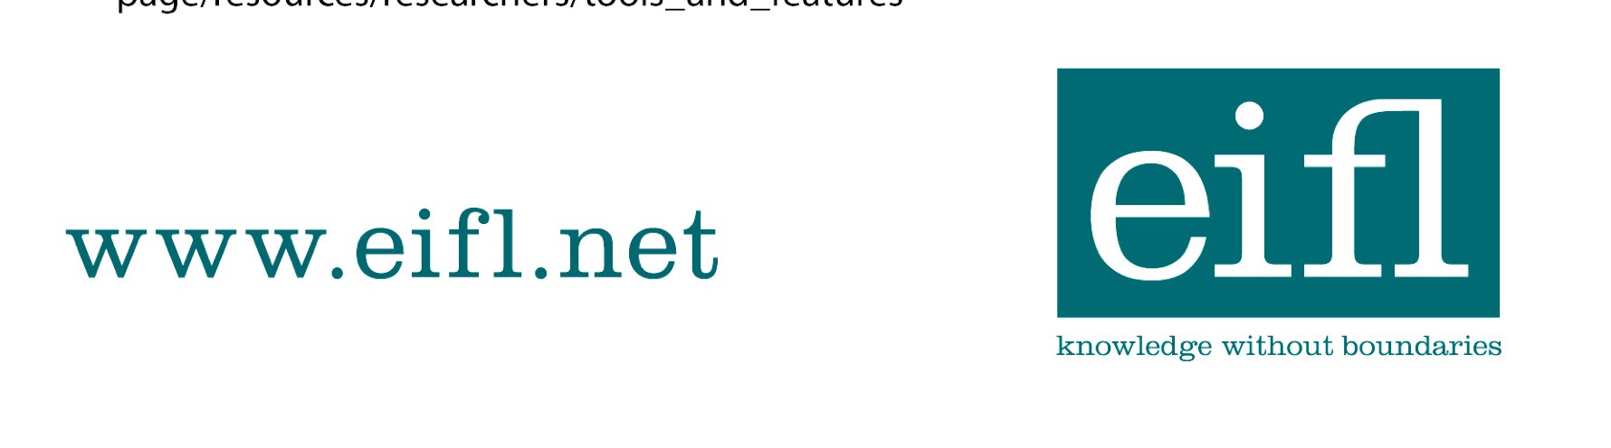

EIFL-FOSS Case Studies

EIFL-FOSS

